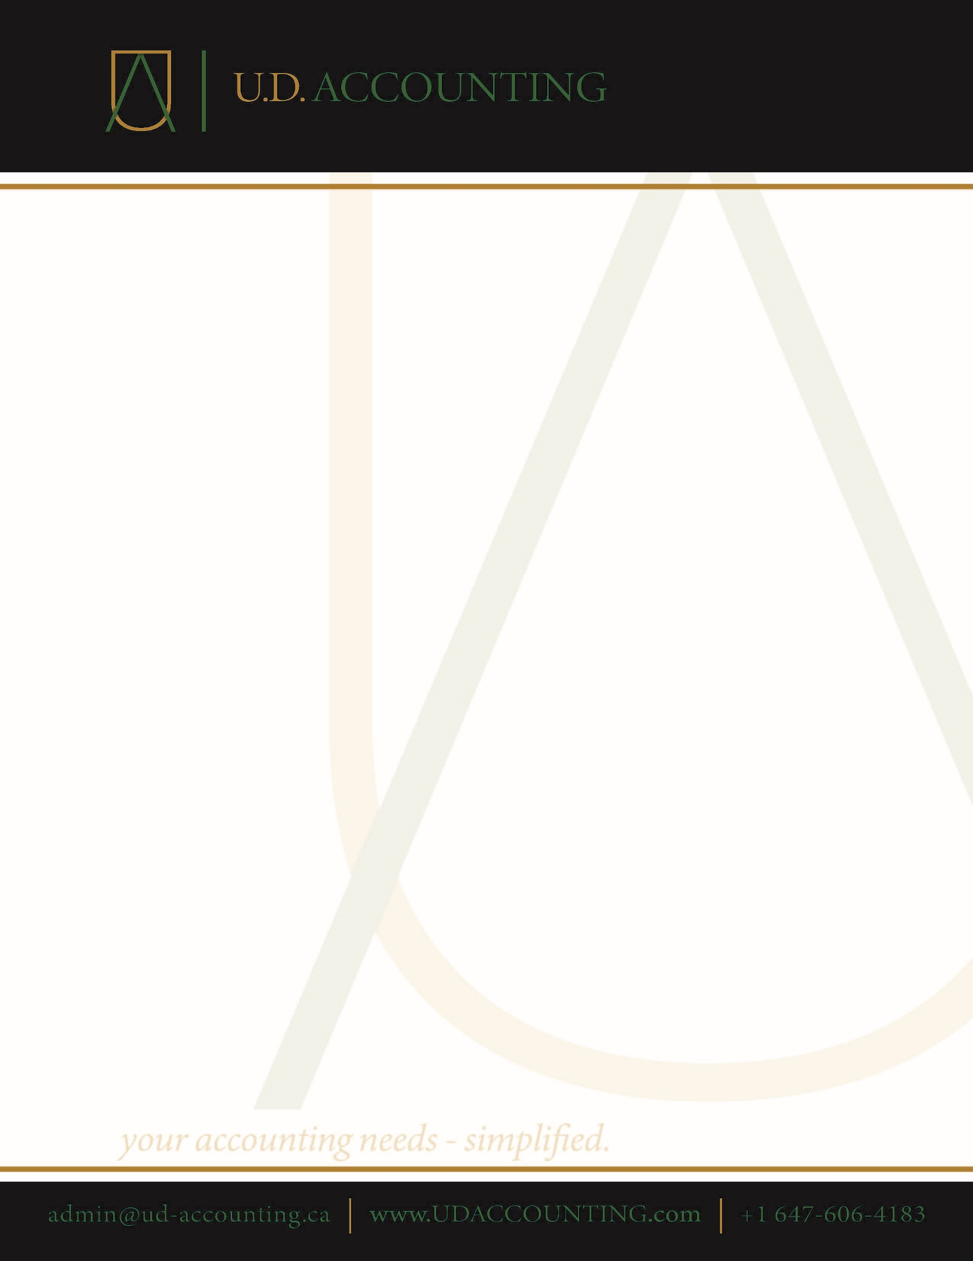z

About the Owner:

Ubayd Deen is a budding accountant and small business owner in the Greater Toronto Area. He has lived and worked in Scarborough for his whole life. He graduated from Ryerson University in 2018 with a major in Accounting. He also has a diploma in Accounting and Finance from Seneca College. He strives to offer efficient and affordable accounting and tax planning solutions and become a household name for everyone in the GTA and surrounding areas.